12. Ivrea – Viverone + Rest Day Viverone
11-12-13th^{th} June

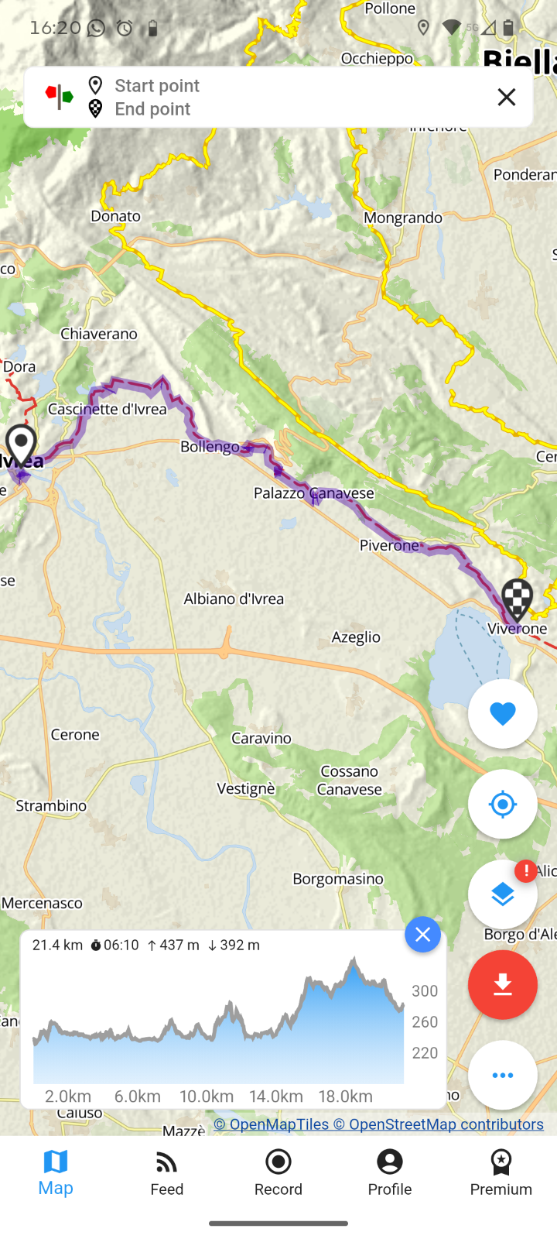

Accomodation viverone

B&B Bouganville
Address: Via al Castello, 2 , 13886 , Viverone , Italy
Phone Numbers: +39 3386396761
Email: paolobobba67@gmail.com
studio apartment with kitchenette, private bathroom and air conditioning for 2 people, plus a 45 m2 apartment with private bathroom and air conditioning for 3 people, and a third 70 m2 apartment with private bathroom for 3 people. Price per person per night including breakfast, towels and sheets 40 euros.

B&B Lagorà
Address: Viale Lun La 12, 13886, Viverone, Biella, Italy
Phone Numbers: +39 3756548580
Email: info@laraviverone.it
B&B on the lakeside of Viverone services dedicated to pilgrims on the Via Francigena: laundry, home restaurant and luggage transfer B&B, No. of beds available 6. Price for overnight stay: 70 with breakfast + 25 euros half board Via Francigena stamp

Roppolo - Affittacamere - Posto Tappa Casa Zola
Address: Via Giacinto Massa n. 15, 13883, Roppolo, Biella, Italy 45.4215740 LATITUDE8.0709629 LONGITUDE
Phone Numbers: +39 3478268924
Email: casaroppolo@gmail.com
3 rooms with 6 beds, shared bathroom, bathroom and bed linen and toiletries are provided.
Refrigerator, coffee machine, kettle for tea/herbal teas, microwave, hairdryer, washing machine.
Bed and Breakfast, No. of places available: 6 OFFICIAL VIE FRANCIGENE STAMP
Price per night: minimum 40 maximum 50 per person per night DISCOUNT FOR OFFICIAL CREDENTIAL HOLDERS: 10%

Roppolo - La Casa del Movimento Lento
Address: Via al Castello 8, 13883, Roppolo, Biella, Italy
Phone Numbers: +39 0161987866
Email: casa@movimentolento.it
It is the home of Alberto Conte, technical manager of the Via Francigena route, author of guides and articles on the itinerary.
- It is possible to rent bicycles, e-bikes and use Apps with GPS tracks of the main itineraries in the surrounding area and guests have access to detailed maps of the area.
- At the House it is possible to purchase credentials for the Via Francigena.
Stamp for credentials and WiFi connection also for pilgrims passing through
25-66 Euro PPPN

